First Aid Policy

[Insert School Name]
This is a Trust model policy. For a School specific policy please visit the School website.

Review Summary
Approved By: | Trust Board
Approval Date: | October 2021
Next Review Date: | October 2024

Policy Index

1. Aims 3
2. Legislation and guidance 3
3. Roles and responsibilities 3
4. First aid procedures 4
5. First aid equipment 5
6. Record-keeping and reporting 6
7. Training 7
8. Contractors working on site 8
9. Monitoring arrangements 8
10. Links with other policies 8
Appendix 1 - List of Trained First Aiders…………………………………………………………………………..…..9
Appendix 2 - Assessment of First Aid Needs Checklist………………………………………..................10
Appendix 3 - HSE Guide to the category and number of first-aid personnel to be available at all times while people are at work……………………………………………………………..........................13
Appendix 4 - What to record on Safesmart………………………………………………………………………..14

Aims
The aims of our first aid policy are to:
- Ensure the health and safety of all staff, pupils and visitors
- Ensure that staff and governors are aware of their responsibilities with regards to health and safety
- Provide a framework for responding to an incident and recording and reporting the outcomes

2. Legislation and guidance
This policy is based on the Statutory Framework for the Early Years Foundation Stage, advice from the Department for Education on first aid in schools and health and safety in schools, and the following legislation:
- The Health and Safety (First Aid) Regulations 1981, which state that employers must provide adequate and appropriate equipment and facilities to enable first aid to be administered to employees, and qualified first aid personnel
- The Management of Health and Safety at Work Regulations 1992, which require employers to make an assessment of the risks to the health and safety of their employees
- The Management of Health and Safety at Work Regulations 1999, which require employers to carry out risk assessments, make arrangements to implement necessary measures, and arrange for appropriate information and training
- The Reporting of Injuries, Diseases and Dangerous Occurrences Regulations (RIDDOR) 2013, which state that some accidents must be reported to the Health and Safety Executive (HSE), and set out the timeframe for this and how long records of such accidents must be kept
- Social Security (Claims and Payments) Regulations 1979, which set out rules on the retention of accident records
- The Education (Independent School Standards) Regulations 2014, which require that suitable space is provided to cater for the medical and therapy needs of pupils This policy complies with our funding agreement and articles of association.

3. Roles and responsibilities

3.1 Appointed person(s) and first aiders
The school’s primary first aiders are responsible for:
- Taking charge when someone is injured or becomes ill
- Ensuring there is an adequate supply of medical materials in first aid kits, and replenishing the contents of these kits
- Ensuring that an ambulance or other professional medical help is summoned when appropriate
First aiders are trained and qualified to carry out the role (see section 7) and are responsible for:
- Acting as first responders to any incidents; they will assess the situation where there is an injured or ill person, and provide immediate and appropriate treatment
- Sending pupils home to recover, where necessary
- Completing an accident report on the Accident Register/Safesmart on the same day, or as soon as is reasonably practicable, after an incident
- Keeping their contact details up to date
School first aiders can be listed using the form in appendix 1. Their names should also be displayed prominently around the school.

3.2 The TPAT CEO and Board of Trustees
The governing board has ultimate responsibility for health and safety matters in the school, but delegates operational matters and day-to-day tasks to the Headteacher and staff members. The Trust will regularly monitor the accidents via reports provided by the Head of Health, Safety & Estates.

3.3 TPAT Health and Safety Team
The Trust’s H&S Team will monitor accidents and incidents reported on Safesmart, look for trends and RIDDOR any accidents as required (See Section 6). The Trust’s Head of Health, Safety and Estates will liaise with the HSE or any other enforcement agencies if triggered by an accident or incident at a Trust school.

3.4 The Headteacher
The Headteacher is responsible for the implementation of this policy, including:
- Ensuring that an appropriate number of trained first aid personnel are present in the school at all times (See Appendix 3)
- Ensuring that first aiders have an appropriate qualification, keep training up to date and remain competent to perform their role
- Ensuring all staff are aware of first aid procedures
- Ensuring appropriate risk assessments are completed and appropriate measures are put in place
- Undertaking, or ensuring that managers undertake, risk assessments, as appropriate, and that appropriate measures are put in place
- Ensuring that adequate space is available for catering to the medical needs of pupils

3.5 Staff
School staff are responsible for:
- Ensuring they follow first aid procedures
- Ensuring they know who the first aiders in school are
- Completing accident reports for all incidents they attend to where a first aider is not called
- Informing the Headteacher or their manager of any specific health conditions or first aid needs

4. First aid procedures

4.1 In-school procedures
In the event of an accident resulting in injury:
- The closest member of staff present will assess the seriousness of the injury and seek the assistance of a qualified first aider, if appropriate, who will provide the required first aid treatment
- The first aider, if called, will assess the injury and decide if further assistance is needed from a colleague or the emergency services. They will remain on scene until help arrives
- The first aider will also decide whether the injured person should be moved or placed in a recovery position
- If the first aider judges that a pupil is too unwell to remain in school, parents will be contacted and asked to collect their child. Upon their arrival, the first aider will recommend next steps to the parents
- If emergency services are called, a member of the Senior Leadership Team will contact parents immediately
- The first aider will complete an accident report form/log on Safesmart on the same day or as soon as is reasonably practical after an incident resulting in an injury. The report will include as much detail as possible, such as weather conditions, surface condition, witnesses (statements to be collected) etc. and must include the address of the injured person.
- Details entered on Safesmart must be updated once the outcome of the injury is known, i.e. if they went to hospital, what the outcome of the hospital visit was and the date they returned to school.

4.2 Off-site procedures
First Aid kits will be taken on all off-site activities, along with individual pupil’s medication such as inhalers, epi-pens etc. Staff who are first aid trained will accompany all off-site visits and for some trips with additional risks or hazards, a Paediatric First Aider may also attend.
When taking pupils off the school premises, staff will ensure they always have the following:
- A school mobile phone
- A portable first aid kit
- Information about the specific medical needs of pupils
- Parents’ contact details
Risk assessments will be completed by the lead teacher prior to any educational visit that necessitates taking pupils off school premises.
There will always be at least one first aider on school trips and visits. As required by the statutory framework for the Early Years Foundation Stage for any EYFS trips this person will hold a current Paediatric First Aid Certificate.

5. First aid equipment
5.1 A typical first aid kit in a school will include the following:
- A leaflet with general first aid advice
- Regular and large bandages
- Eye pad bandages
- Triangular bandages
- Adhesive tape
- Safety pins
- Disposable gloves
- Antiseptic wipes
- Plasters of assorted sizes
- Scissors
- Cold compresses
- Burns dressings

No medication is kept in first aid kits.

First aid kits are stored in:
- The medical room
- Reception
- All classrooms
- The school halls
- The school kitchen

5.2 Asthma Pumps/Epi-pens
Schools purchase asthma pumps/epi-pens to use in an emergency where parental consent has been given. School equipment would be administered where the child’s own resources were unavailable. Pupils who require asthma pumps and Epi-pens are required to have two working pumps or Epi-pens in school in their classroom. If these should fail, the school equipment will be utilised, having secured parental agreement previously on initial notification of the pupil’s need for critical medication. Any such events will be recorded in the Asthma Pump/EpiPen folder located in the medical Room.

6. Record-keeping and reporting

6.1 First aid and accident record book
- An accident will be recorded by the first aider on the same day or as soon as possible after an incident resulting in an injury on the Accident Register/Safesmart (see Appendix 4 for details of which injuries should be reported on Safesmart)
- Details when reporting an accident will include the date, time of accident/incident, child’s name, a brief summary of the accident and action taken.
- A copy of the accident report will also be added to the pupil’s educational record by the School Office Administrative staff
- Records held in the Accident Register will be retained by the school for a minimum of 3 years, in accordance with regulation 25 of the Social Security (Claims and Payments) Regulations 1979, and then securely disposed of.

6.2 Reporting to the HSE through Safesmart
The Trust will report any accidents that are RIDDOR reportable to the HSE. HSE guidance on reporting incidents in schools can be found in the HSE information sheet
Reportable injuries, diseases or dangerous occurrences include:
- Death
- Specified injuries, which are:
  - Fractures, other than to fingers, thumbs and toes
  - Amputations
  - Any injury likely to lead to permanent loss of sight or reduction in sight
  - Any crush injury to the head or torso causing damage to the brain or internal organs
  - Serious burns (including scalding)
  - Any scalping requiring hospital treatment
  - Any loss of consciousness caused by head injury or asphyxia
  - Any other injury arising from working in an enclosed space which leads to hypothermia or heat-induced illness, or requires resuscitation or admittance to hospital for more than 24 hours
  - Injuries where an employee is away from work or unable to perform their normal work duties for more than 7 consecutive days (not including the day of the incident)
  - Where an accident leads to someone being taken to hospital
  - Injuries where an employee is away from work or unable to perform their normal work duties for more than 7 consecutive days (not including the day of the incident)

Physical Assault/Injury
Staff should complete an accident form if they or a pupil, staff or parent/carer have been physically assaulted or injured by another pupil. The form should include a timeline leading to the assault, any triggers and resulting behaviours.

Near Miss Events

Near-miss events that do not result in an injury, but could have done should be recorded via the Safesmart accident reporting system.
Examples of near-miss events relevant to schools include, but are not limited to:
- The collapse or failure of load-bearing parts of lifts and lifting equipment
- The accidental release of a biological agent likely to cause severe human illness
- The accidental release or escape of any substance that may cause a serious injury or damage to health
- An electrical short circuit or overload causing a fire or explosion

Information on how to make a RIDDOR report is available here: How to make a RIDDOR report, HSE http://www.hse.gov.uk/riddor/report.htm

6.3 Notifying parents/carers
The school will inform parents of any accident or injury sustained by a pupil, and any first aid treatment given, on the same day, or as soon as reasonably practicable.

7. Training
The Headteacher will ensure that the school has adequate first aid trained staff based on the needs of the school following risk assessment.

- The school will keep a register of all trained first aiders, what training they have received and expiry date, this is recorded on the Single Central Register.
- Staff are encouraged to renew their first aid training when it is no longer valid.
- The Headteacher will ensure that there are enough staff trained in paediatric first aid in early years to ensure cover for absence. This meets the requirements set out in the Early Years Foundation Stage statutory framework and is updated at least every 3 years.

8. Contractors working on site
All contractors working on site, whether cleaning staff or tradesmen, must be made aware of the first aid procedures on site including who they should notify if there is an accident. See Management of Contractors Policy

9. Monitoring arrangements
This policy will be reviewed by the Trust every three years or following a change in legislation/school procedure. At every review, the policy will be approved by the Local Governing Board Committee.

10. Links with other policies
This first aid policy is linked to the
- Health and Safety Policy
- Management of Contractors Policy

APPENDIX 1: list of trained first aiders
Full Name | Training | Location | Date

APPENDIX 2: Assessment of first aid needs checklist.

Issues to consider | Impact on first aid provision | Notes
Hazards:
The findings of the risk assessment(s) should be taken into account, along with parts of the workplace that may have different work activities or hazards, and may require different levels of first aid provision.
Are the hazards low level, such as those found in offices? | The minimum provision is:  - An appointed person to take charge of first aid arrangements;  - A suitable first aid box.
Are there higher-level hazards such as dangerous machinery, hazardous substances, or work involving confined spaces? | Consider:  - Providing first-aiders;  - Additional training for first-aiders to deal with injuries resulting from special hazards;  - Additional first aid equipment;  - Precise siting of first aid boxes;  - Providing a first aid room;  - Informing the emergency services.
Does the level of risk vary in different parts of the establishment/building/site? | Consider the provision of each building or site.  Where several levels of risks exist, base the provision on the highest level of risk.
Employees
How many people are working on site, or in the establishment/building? | Where there are small numbers of employees, the minimum provision is:  - An appointed person to take charge of first aid arrangements;  - A suitably stocked first aid box.  Where there are large numbers of employees, consider providing:  - First-aiders;  - Additional first aid equipment;  - A first aid room.
Are there any inexperienced staff, or trainees on site? | Consider:  - Additional training for first-aiders;
Are there any staff with disabilities, or particular health problems? | - Additional first aid equipment;  - Local siting of first aid equipment.  The first aid provision should cover any work experience trainees.

Non-employees
Do members of the public visit your premises? | Under the Regulations, there is no legal duty to provide first aid for non-employees but the HSE strongly recommends that non-employees be considered in the first aid provision.  Where there are small numbers of non-employees, a guide to the minimum provision is:  - An appointed person to take charge of first aid arrangements;  A suitably stocked first aid box  Where there are large numbers of non-employees, consider providing:  - First-aiders;  - Additional first aid equipment  - A first aid room.  Where non-employees have disabilities or particular health problems, consider:  - Additional first aid equipment;  - Precise siting of first aid boxes;  - Providing a first aid room;  - Additional training for first-aiders to deal with disabilities or particular health issues, for example the use of an epi-pen for administration.
Accident and ill health record
What is the record of previous accidents or incidents of ill health?  What injuries and illnesses have occurred and where did they happen? | Ensure the first aid provision will cater for the type of injuries and illnesses that might occur. Monitor accidents and ill health and review the first aid provision as appropriate.

 | Working arrangements
 | Do staff work out of normal office hours or work shifts? | Ensure there is adequate first aid provision at all times people are at work.
 | Do staff travel to other sites, work remotely or work alone? | Consider:  - The outcomes of the lone working risk assessment;  - Issuing personal first aid kits;  - Issuing personal communicators or mobile phones.
 | Does the work involve travel to other sites or locations with members of the public (clients, service users or pupils)? | Consider:  - Ensuring the group is accompanied by a first aider;  - Taking a first aid kit on the trip;  - The medical needs of the clients, services users or pupils, particularly if they have a medical care plan.
 | Do staff work at sites of other organisations? | Consider:  - Making arrangements with the other organisation(s) to ensure adequate first aid provision;  - A written agreement between yourself and the other organisation(s).
 | Is there sufficient first aid provision to cover absences of first-aiders, or appointed persons? | Consider:  - What first aid provision would be required to cover for annual leave or other planned absences;  - What would be required to cover for unplanned and exceptional absences?
Overall Risk Rating based on information in table above (circle as appropriate): |  |  |  |  | High |  | Medium | Low
Maximum number of persons on site, including non-employees:
 | Number of 3-day trained first-aiders required: |  |  | Number of Emergency first-aiders required:
 | Number of First Aid boxes required: |  |  | Number of Travelling/Mobile first aid kits required:
 | Name of person responsible for maintaining the first aid boxes and kits: |  |  | Name of person responsible for organising refresher training:
 | Signed: |  |  | Date: |  | Date of Review:

APPENDIX 3 - HSE Guide to the category and number of first-aid personnel to be available at all times while people are at work

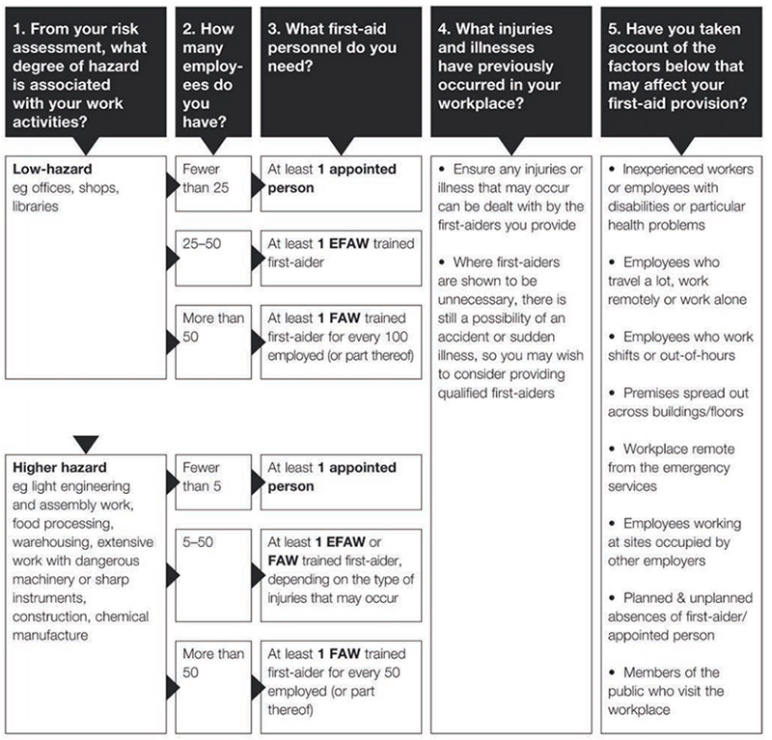

APPENDIX 4 – What to record on Safesmart

The following accidents or incidents must be reported on Safesmart within 5 working days:
- All deaths and any act of physical violence. (Deaths must immediately be
reported to TPAT Head of Health, Safety and Estates or Chief Executive Officer.)

- Any injury which resulted in the individual
(student/staff/parent/contractor/visitor) being taken
straight to hospital/doctor/emergency dentist.

- Any injury which resulted in the individual
(student/staff/parent/contractor/visitor) being taken
home and then going to hospital/doctor/emergency
dentist (even if a few days have passed).

- All head injuries must be reported.

- All staff injuries must be reported including incidents of
work-related stress.

Within 72 hours, any submitted reports must be updated with the outcome of any hospital visits/ when they returned to school etc.

