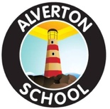

Vacancy Information Pack

School Name: | Alverton Primary School
Job Title: | Nursery Practitioner

Information Pack Contents
Advertisement | Provided in this document
School Information for Applicants | Provided in this document
Welcome to Our School | Provided in this document
General Background | Provided in this document
Class Organisation | Provided in this document
Staff Organisation | Provided in this document
Our Curriculum | Provided in this document
Safeguarding | Provided in this document
Application Information | Provided in this document
Job Description | Attached
Person Specification | Attached
Letter from Chair of Board of Trustees | www.tpacademytrust.org/application-packs/
Application Form | www.tpacademytrust.org/application-packs/
Equality and Diversity Monitoring Form | www.tpacademytrust.org/application-packs/

Alverton Primary School

Job Title: | Nursery Practitioner (Band 2)
Pay Point / Pay Range: | TPAT Point 4
Full Time Equivalent Annual Salary: | £20,436 (if paid over 52 weeks) pro rata
Actual Annual Salary for this Role: | TBC
Contract Type: | Permanent
Hours Per Week / Weeks Per Year | Hours – TBC  Working Weeks – 52 working weeks  Paid Weeks – 52.14 paid weeks
Closing Date: | 12 midnight on 3rd February 2023
Proposed Shortlisting Date: | TBC
Proposed Interview Date: | 10th January 2023

[To find out more about Alverton School, please visit: | http://www.alverton.org.uk/website
To discuss this position please contact the Nursery Lead, Mrs Holmes | Email: woodlandnursery@alverton.tpacademytrust.org  Telephone: 01736 351135
Application packs can be downloaded from: | www.tpacademytrust.org/application-packs/
Please email your completed application form and equality & diversity monitoring form by the closing date to: | Miss Kayla Statham  woodlandnursery@alverton.tpacademytrust.org
Please note that successful candidates will be informed via email.

Truro and Penwith Academy Trust is committed to safeguarding and promoting the welfare of children and young people and expects all of our staff and volunteers to share this commitment. Applicants must be willing to undergo child protection screening and pre-employment checks, including enhanced DBS clearance and full reference checks with previous employers.
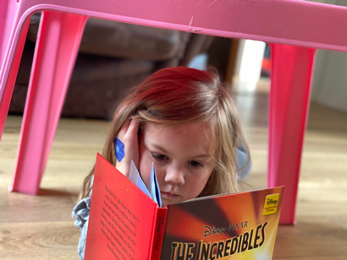
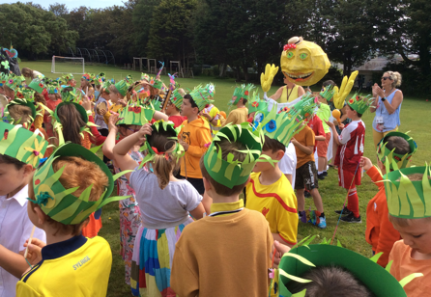
School Information for Applicants
School Address: | Alverton Primary School, Toltuff Crescent, Penzance, Cornwall TR18 4QD
School Telephone Number: | 01736 364087
School Email Address: | alverton@tpacademytrust.org
Name of Headteacher: | Mr Martin Higgs
Website Address: | http://www.alverton.org.uk/website  https://woodlandnursery.eschools.co.uk/web
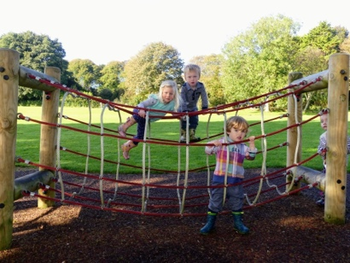

Welcome to Our School
This information pack will provide you with an insight into our school and offer some practical information which will be of use to you as a prospective member of our school community.

At Alverton, we are committed to providing a stimulating, creative environment where everyone feels valued and safe, and pupils can flourish and reach their full potential.
By providing a broad, balanced and engaging curriculum, and by promoting good behaviour and respect for all, we aim to enthuse all children with a love of learning and to foster a caring environment for all.

Whatever the needs of a child, we aim to ensure that our pupils grow, feel safe, have fun and enjoy success. We want our pupils’ time at Alverton to be memorable and to encourage them to become lifelong learners. We actively safeguard and promote pupils’ welfare and we want everyone in our school community to feel a sense of pride and ownership in what we achieve together in providing the best possible learning opportunities for our pupils.

Mr Martin Higgs (Headteacher)

Our School enjoys working collaboratively with our partner schools within Truro and Penwith Academy Trust.
We welcome visitors as this is the best way to see our lovely school, experience our creative and captivating curriculum and meet our motivated and engaged children. Please phone the school telephone number provided if you would like to arrange to look around.
General Background
Alverton School is located between Penzance and Newlyn, approximately half a mile from the sea.
We cater for children between the ages of 3 and 11, plus our Woodland Nursery which offers care from 2 years old. We currently have 308 pupils on roll and offer a broad and engaging curriculum, as well as a full programme of before and after-school activities. In 2017, we joined the Truro and Penwith Academy Trust and enjoy working collaboratively with our partner schools as well as having excellent links with both Humphry Davy and Mounts Bay secondary schools.

Class Organisation
The school currently has 308 children on roll in twelve classes.
Upper Key Stage 2: Kenidjack – Mr Hammond; Bosigran – Mrs Harman and Mrs Stellon; Bodrifty – Mrs O’Rourke
Lower Key Stage 2: Kerris – Mrs Clemens and Mrs Stellon; Lanyon – Miss Mason; Trencrom – Miss Rudge
Key Stage 1: Kingfishers – Mr Dawe; Owls – Mrs Clive; Puffins – Mrs Hughes and Mrs Goddard
EYFS Reception: Kittiwakes – Mrs Simpson; Curlews – Mrs Daylak
EYFS Nursery: Our Nursery has a Pre-School Room (Little Owls) led by Mrs Hanley, one of our teachers, and a Toddler Room (Foxes) led by Miss Statham, the Room Lead.

Staff Organisation
The school has a Headteacher (Mr Higgs), a Deputy Headteacher (Mrs Wicks), nine full-time teachers, five part-time teachers, a SENDCo (Mrs Hughes – 1.5 days each week) and a part-time PE teacher (Mr Timmons). In addition, we have four HLTAs and twenty teaching assistants, all of whom are a key part of our teaching and learning team.
Our Woodland Nursery Lead Miss Statham. She is supported by ten Nursery Practitioners, including a SENDCO.
We also have a fabulous office team who are integral to the running of the school. Both our catering and cleaning contracts are provided by outside companies.
We are strongly committed to staff development and learning.

Our Curriculum
At Alverton, we want to give every child the very best learning experience that we can. We provide a rich and exciting curriculum that promotes independence and opportunities for everyone, regardless of individual need, to succeed. We aim to give them the academic knowledge, skills and cultural capital they need to allow them to progress confidently onto their future learning and into the world. We feel that reading is fundamental to a child’s success and ensure that this is embedded throughout the curriculum.
All staff have a shared ethos and high expectations for all our pupils and celebrate their successes in all aspects of school life, encouraging pupils to reach their full potential and adapting the curriculum to meet the needs of every pupil. We deliver a coherently planned and sequenced, broad and varied curriculum which is hugely engaging and designed to ensure that all of our children succeed and love to learn.
We take a cohesive and coherent approach towards the planning, sequencing and delivery of lessons in order to ensure the children accumulate the knowledge and skills needed for future learning. Each key stage follows a rolling programme of umbrella headings which ensures full and rigorous curriculum coverage in all year groups, enabling pupils to revisit and remember the content and skills they have been taught and to link these into new learning.
We firmly believe that our pupils need to be prepared for life in a technological world. We use iPads across the curriculum to enhance learning, develop IT skills and ensure that all pupils are enabled to access learning and record their work in a variety of ways.
We have fantastic grounds at Alverton and take every opportunity to enhance the children’s experiences at school through using this for woodland activities and outdoor education.
From Reception through to Year 6, we take opportunities to extend the curriculum through visitors, including artists and musicians. We also use our amazing grounds as much as possible and get out and about in the locality and the wider environment. In addition, we plan educational visits to enhance the children’s learning to places such as Feadon Farm, the museum in Truro, the Minack theatre or St Michael’s Mount.
There are many opportunities for excellence beyond the classroom such as through our highly successful sports teams or our annual musical production. Excellent links with both local secondary schools provide many enrichment activities for Key Stage 2 including in dance, art and sport.
Years 3 to 6 have the opportunity to spend time at a residential centre during the Summer Term. This helps to develop self-reliance, co-operation and initiative as well as giving the children the chance to experience different activities and environments. These trips are also, of course, great fun! Our residential visits range from camping and outward-bound activities at Porthpean to an unforgettable trip to London including Legoland and a West End show!
Early Years Foundation Stage
Children in our youngest classes are immersed in the prime areas of learning in a safe and stimulating environment. We consider the individual needs, interests, and stage of development of each child in our care, and use this information to plan a challenging and enjoyable experience for each child in all of the areas of learning and development.
We aim to create experiences which encourage children to think creatively and explore the world as they see it. We recognise the importance of play-based learning as well as the benefits that being outside can bring.
At the Woodland Nursery, we aim to give every child the best possible foundation on which to build their whole education. We aim to enable children to become resilient, independent and confident learners, ready for the next stage of their education. We aim to create awe and wonder of the world, a rich and engaging curriculum and a lifelong love of learning and use our fabulous outdoor environment as much as we can.

Safeguarding
TPAT is committed to safeguarding and promoting the welfare of children and young people and expects all staff, workers and volunteers to share this commitment.
Shortlisted candidates will be required to complete a Safeguarding Self-Declaration Form as part of their application. Successful candidates will be required to complete a Disclosure and Barring Service (DBS) application and Health Assessment form as part of their pre-employment administration. The amendments to the Rehabilitation of Offenders Act 1974 (Exceptions) Order 1975 (2013 and 2020) provide that when applying for certain jobs and activities, certain convictions and cautions are considered ‘protected’. This means that they do not need to be disclosed to employers, and if they are disclosed, employers cannot take them into account.

Application Information
We hope that you find this pack provides all of the information you need in order to consider your application for the post. Should you have any questions or matters you would like to discuss informally, or to arrange a visit, please contact:
Contact Name: | Miss Kayla Statham
Contact Email Address: | woodlandnursery@alverton.tpacademytrust.org
Contact Telephone Number: | 01736 351135
Please note that CVs will not be accepted.
Application packs can be downloaded from www.tpacademytrust.org/applicationpacks/.
Closing Date: | 3rd February 2023
Completed applications must be returned to the email address above and be received by 12 Midnight on the closing date provided.
Interview Date(s): | 10th February 2023
To ensure the fairness of the selection process, shortlisting will be based upon information which you provide in your application, and assumptions will not be made about your experience or skills. We will look for demonstrable evidence that you meet the criteria set out in the person specification.
If we have not contacted you within 14 days of the closing date, it is unlikely that you have been shortlisted on this occasion. Many thanks for your interest in this post.

Last updated 12 2021

