]

Vacancy Information Pack

School Name: | Landewednack CP School
Job Title: | Nursery Nurse

Information Pack Contents
Advertisement | Provided in this document
School Information for Applicants | Provided in this document
Welcome to Our School | Provided in this document
General Background | Provided in this document
Class Organisation | Provided in this document
Staff Organisation | Provided in this document
Our Curriculum | Provided in this document
Safeguarding | Provided in this document
Application Information | Provided in this document
Job Description | Attached
Person Specification | Attached
Letter from Chair of Board of Trustees | www.tpacademytrust.org/web/application_pack/604811
Application Form | www.tpacademytrust.org/web/application_pack/604811
Equality and Diversity Monitoring Form | www.tpacademytrust.org/web/application_pack/604811

Landewednack CP School
Job Title: | Nursery Practitioner Maternity Cover
Pay Point / Pay Range: | TPAT Pay Point 4
Full Time Equivalent Annual Salary: | £20,436
Contract Type: | Temporary until staff member returns to work
Hours Per Week / Weeks Per Year | Hours – 30 hours per week (possible job share)  Working Weeks – 52 working weeks  Paid Weeks – 52.14 paid weeks
Closing Date: | 12 midnight on 29/1/2023
Proposed Shortlisting Date: | 30/1/2023
Proposed Interview Date: | 2/2/2023

Landewednack CP School, part of Truro and Penwith Academy Trust, are looking for a kind, caring and enthusiastic person, with a suitable level 3 qualification in childcare, to cover maternity leave in their nursery.

This position would require the successful candidate to work 30 hours per week between the hours of 8am and 5pm, Monday to Friday. The nursery is open for 50 weeks of the year.

The successful candidate will be responsible for supervising the children, ensuring their safety at all times, engaging with them in aspects of play and conversation, setting up activities for children to optionally take part in, meeting and greeting parents and providing them with feedback on their child’s time at the nursery.

For more details or an application form, please contact Sue Tattersall by emailingsecretary@landewednack.cornwall.sch.uk or by phoning 01326 290337 option 1. Please note we do not accept CVs and only applications submitted on an application form will be considered.

Landewednack CP School is a small school of 74 children plus a nursery unit, located in the village of The Lizard, twelve miles from Helston. Our school is a THRIVE school and has a strong ‘family’ ethos where every child is valued, nurtured and helped to be the best they can be.

Please read the job specification before applying for the post.

Visits to the nursery are strongly encouraged.
To find out more about Landewednack CP School, please visit: | www.landewednack.cornwall.sch.uk
To discuss this position please contact the Headteacher: | Email – secretary@landewednack.cornwall.sch.uk  Telephone – 01326 290337
Application packs can be downloaded from: | www.tpacademytrust.org/web/application_pack/604811
Please email your completed application form and equality & diversity monitoring form by the closing date to: | Mrs Sue Tattersall  secretary@landewednack.cornwall.sch.uk
Please note that successful candidates will be informed via email.
The Trust is committed to safeguarding and promoting the welfare of children and young people and expects all staff, workers, volunteers, governors and trustees to share this commitment. All successful applicants will be subject to appropriate pre-employment checks and will be required to complete a Disclosure and Barring Service (DBS) Enhanced Check, a Safeguarding Self-Declaration Form and satisfactory online searches undertaken.
School Information for Applicants
School Address: | Landewednack CP School  Beacon Terrace  The Lizard  Cornwall  TR12 7PB
School Telephone Number: | 01326 290337
School Email Address: | secretary@landewednack.cornwall.sch.uk
Name of Headteacher: | Mrs Louise Jones
Website Address: | www.landewednack.cornwall.sch.uk

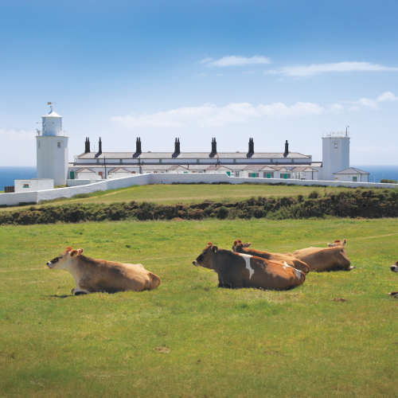
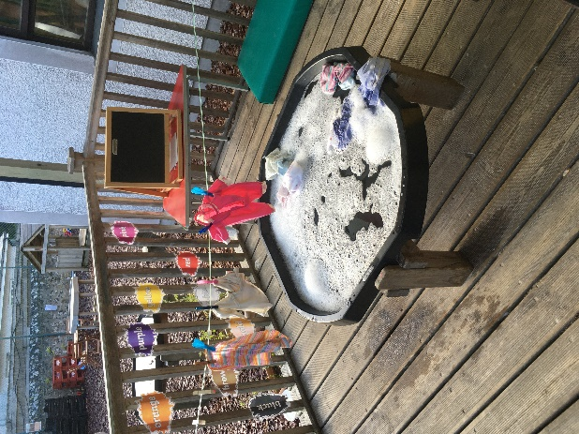
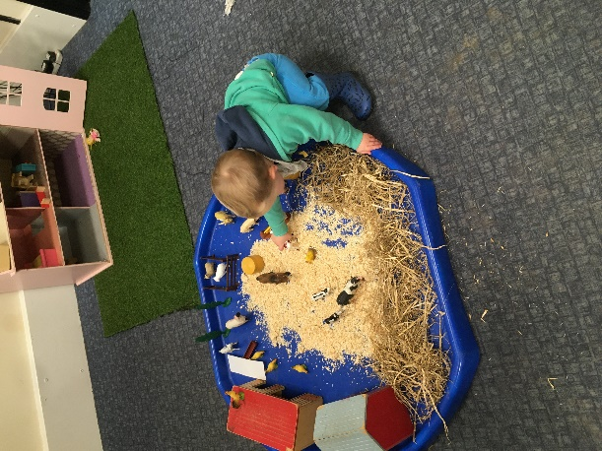
When the Two Fairies Visited to Turn our Playground into a Winter Wonderland!
The view from our school gate
Some Activities in our Nursery

Welcome to Our School
This information pack will provide you with an insight into our school and offer some practical information which will be of use to you as a prospective member of our school community.
Landewednack Community School is a notable example of everyone—teachers, support staff, governors, parents, community volunteers and, of course, children — working together happily and successfully. The school has had many achievements and is constantly seeking to add to them. Our guiding principles are academic success, a supportive family ethos and being at the heart for our local community.
Landewednack School delivers a broad and balanced curriculum to all of our children, ensuring that those with special educational needs, disabilities or medical conditions are included as fully as possible in all aspects of school life. Thanks to its team spirit, Landewednack Community School continues to meet today’s ever-tougher challenges and to build on its successes.
Our School enjoys working collaboratively with our partner schools within Truro and Penwith Academy Trust.
We welcome visitors as this is the best way to see our lovely school, experience our creative and captivating curriculum and meet our motivated and engaged children. Please phone the school telephone number provided if you would like to arrange to look around. We look forward to welcoming you into our happy school.
General Background
Landewednack is in The Lizard village, well known as the most southerly point on Britain’s mainland, at the tip of the Lizard Peninsula.
Children come from the village and across the surrounding Lizard area. The Little Lizards Nursery adjoins the school building and offers provision for children from 2 years to school age. We also offer a Breakfast, After-School Club for children at Landewednack School, and a holiday club which is open to children between 2 – 11 from any primary school/nursery on the peninsula – places are booked by contacting Little Lizards. Children join the reception class in the September following their 4th Birthday - see our Admissions Policy. At the end of Year 6 the majority of our pupils transfer to Mullion School, following planned transition events from Year 5 onwards.

Class Organisation
Little Lizards Nursery – 2 – 4 years - June Evans and Camilla Roberts (inc. breakfast club from 8am)
Pufflings – reception – Mrs Gulley and Mrs Humby
Puffins – year 1 and 2 – Miss Carey, Mrs Turner and Ms Hughes
Choughs – year 3 and 4 – Miss Kennedy, Miss Hughes and Mrs Broscomb
Razorbills – year 5 and 6 – Miss Triggs and Mrs Nicholas
Afterschool club is run by Angela Haskell and Liz Hill, who also provide TA cover across the school when needed.

Staff Organisation
The Headteacher is Mrs Louise Jones, assisted by Assistant Head Miss Rebecca Carey. We have a SENDCO (Mrs Green – 1 day a week). Our 4 class teachers are supported at different times during the day by our 6 TAs to help provide an inclusive, broad and balanced curriculum to all of our children.
Our Nursery Manger is Mrs June Evans, supported by Mrs Camilla Roberts, who work hard to give our children the foundations they will need to build on throughout their school life.
Afterschool club is run by Angela Haskell and Liz Hill, who also provide TA cover across the school when needed.
Mrs Sue Tattersall is our School Secretary, with Mrs Lyndsay Bray organising our sporting fixtures and communicating with parents and our wider community via newsletter, website and local papers.
Our cleaner, Mrs Shona McIntosh, does a brilliant job keeping our school clean. Our catering is provided by Chartwells, who employ Mrs Kelly Pengilly, our cook, who is helped in the kitchen by Mrs Nicole Woods.
We are strongly committed to staff development and learning.

Our Curriculum
At Landewednack, we have designed an ambitious curriculum for our children which is based on the application of the National Curriculum and EYFS Curriculum within our unique context. This is underpinned by our vision and values.
Our curriculum driver ‘Social Responsibility’ emphasises the importance of understanding world events and our local context. Therefore, we have designed our curriculum to be adaptable to the ever-changing world.
Whilst we celebrate our local context, we recognise the need to enrich our children’s experience with ‘Diversity’ that they may not otherwise experience.
‘Eloquence’ drives all we do; research shows that children who have a wide vocabulary and an ability to communicate well have the best life chances.
Our driver ‘Independence’ is created from the need to build our children’s resilience, equip them with the opportunities and ‘tools’ to learn and succeed, and links with our driver ‘Aspiration’; as well as ensuring our children are happy, well supported and confident, we want to foster high academic aspirations and attitudes to learning as well as developing the skills they will need for success in higher education and in future careers.
Please follow this link http://www.landewednack.cornwall.sch.uk/website/our_curriculum_/241176 for more information about our curriculum.

Safeguarding
TPAT is committed to safeguarding and promoting the welfare of children and young people and expects all staff, workers, volunteers, governors and trustees to share this commitment.
Shortlisted candidates will be required to complete a Safeguarding Self-Declaration Form as part of their application. We will also carry out online searches as part of our due diligence on the shortlisted candidates, as updated in the Keeping Children Safe in Education recommendations. This may help identify any incidents or issues that have happened, and are publicly available online, which the School or Trust might want to explore with the candidate at interview.
Successful candidates will be required to complete a Disclosure and Barring Service (DBS) application and Health Assessment form as part of their pre-employment administration. The amendments to the Rehabilitation of Offenders Act 1974 (Exceptions) Order 1975 (2013 and 2020) provide that when applying for certain jobs and activities, certain convictions and cautions are considered ‘protected’. This means that they do not need to be disclosed to employers, and if they are disclosed, employers cannot take them into account.

Application Information
We hope that you find this pack provides all of the information you need in order to consider your application for the post. Should you have any questions or matters you would like to discuss informally, or to arrange a visit, please contact:
Contact Name: | Mrs Sue Tattersall
Contact Email Address: | secretary@landewednack.cornwall.sch.uk
Contact Telephone Number: | 01326 290337 (option 1)
Please note that CVs will not be accepted.
Application packs can be downloaded from: www.tpacademytrust.org/web/application_pack/604811
Closing Date: | 12 midnight on 29/1/2023
Completed applications must be returned to the email address above and be received by 12 Midnight on the closing date provided.
Proposed interview Date: | 2/2/2023
To ensure the fairness of the selection process, shortlisting will be based upon information which you provide in your application, and assumptions will not be made about your experience or skills. We will look for demonstrable evidence that you meet the criteria set out in the person specification.
If we have not contacted you within 14 days of the closing date, it is unlikely that you have been shortlisted on this occasion. Many thanks for your interest in this post.

